**STATE UNIVERSITY OF BANGLADESH (SUB)**



**Course No: CSE-0317**

**Course Name: Software Engineering**

**Semester: 10th**

**Submitted to:**

**Khan Md. Hasib**

**Lecturer,**

**Department of CSE, SUB**

**Submitted By:**

**Name: Yeasmin Akter**

**ID:** UG02-48-18-013

**Batch: 48**

**Email:** yasminepsha@gmail.com

**TopOfStack Software**

**1. COMPANY PROFILE**

TopOfStack company started their journey from November 2008. TopOfStack software package Ltd. is associate degree robot developer that has been active since 2013. The present app portfolio contains thirty apps. Overall, it has a tendency to estimate that TopOfStack software package Ltd.' apps have collected regarding nine million installs, one hundred thousand of them within the last 30 days. Associate degree particularly well-liked app is contact backup that is one among the additional popular apps in Google Play with over one million installs.

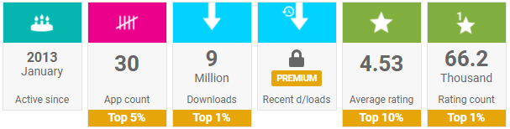

**Figure 1: Company Statistics**

**2. COMPANY TYPES**

TopOfStack software package Ltd. is a type of partnership firm. The company is specialized in development and distribution of software and technologies for iOS, Android & Windows concerning App, Web & Design. With a crew of developers, designers, marketers, executives, TopOfStack Software Ltd. has added extra than 350 apps for Appstore, playstore, Windows-shop and advanced a several internet site with appealing photos design.

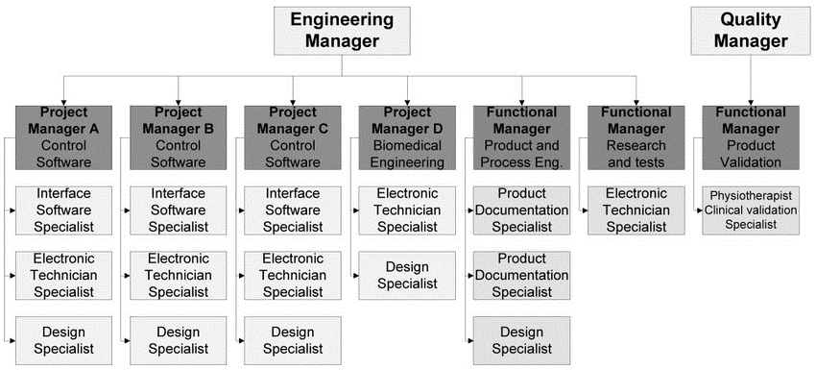

**Figure 2: Organizational Structure**

**3. COMPANY OBJECTIVES**

i. To enhance customer satisfaction and improve usability by modern UI/UX design for smart phones.

ii. To standardize and codify key software project concepts and terminology

iii. To develop an accurate and flexible model describing key project activities

iv. To encourage a spirit of openness, transparency, integrity, trust, and continuous learning

v. To build and nurture a global community that shares our vision and mission

1. **DEPARTMENTS AND CLINTS**

**1. WEB DEVELOPMENT:**

TopOfStack Software Ltd. is the best web design & development company with strong frontend backend team. It provides customized corporate level web solutions for e-Commerce, Services, Finance, Education etc. We support with complex Database design, Admin panel, API/Web-services (REST, SOAP, JSON, XML)

**2 .UI/UX DESIGN:**

TopOfStack Software Ltd. is top UX/UI designer company designs creative graphics for iOS, Android apps with Appstore, Playstore guidelines. To enhance customer satisfaction and improve usability by modern UI/UX design for smart phones. Our User interfaces are clear, simple, and responsive for different devices.

**3 .MOBILE APPS DEVELOPMENT:**

As Top mobile developer company, TopOfStack Software Ltd. delivered numerous iPhone,Android apps with eye catching Graphics Designs for different business likes Education, Consumer, Finance, Services, e-Commerce, Employment, Religion etc.

**4. CLIENT SERVICES :**

**There are many types of services give us in this company. Such as:**

1. **Mobile App development**
2. **Software Development**
3. **Web Design & Development**
4. **E-commerce Development**
5. **Block chain Technology**
6. **Digital Marketing**
7. **SEO services**
8. **Graphics Design**

**1. Mobile app development Services:**

TopOfStack the award-winning mobile app focus on the two main services of mobile apps.

1. Android App Development

2. iOS App Development

**2. Web Design & Development:**

TopOfStack Software specializes in website design and development services. The web experiences are high-performing, feature-packed and digitally trans formative, designed to be user-friendly, fully functional, very secure and able to scale as your enterprise grows. The website is an instrument that helps to take business to the next level and web development is the founding pillar on which your website is built! TopOfStack is the best web design & development company in Bangladesh.

**3. Software Development :**

Best software development Company in Bangladesh is TopOfStack. More than 11+ years experience of developing performing software for your business. Software development company, We provide web based software development in Bangladesh. Custom software development is the process of creating a software that is precisely developed for the user or a group of users within an association. Customized software development includes the commissioning, development and deployment of a software product which is tailored as per client’s customization features requirements. Our universal software outsourcing model make sure we deliver maximum targeted result to our client. Software development is the computer programming, documenting, testing, and bug fixing involved in creating and maintaining applications and frameworks involved in a software release life cycle and resulting in a software product.

**4. Digital Marketing:**

TopofStack Software is the top digital marketing company in Bangladesh. We provide best digital marketing services in Bangladesh. Digital Marketing is the process of building and maintaining a customer relationship with the help of digital technologies or electronic media. It helps you to generate online income and enhance customer traffic on your business website. Shared some of the most popular Digital marketing techniques which helps you to grow your online businesses:

1. Search engine optimization (SEO) is a process of optimizing web traffic on a specific website through organic search engine results and helps to enhance the website ranking in search engine pages.

2. Content marketing is the process of creating high-quality content for the promotion of a specific product and helps to generate online sales by increasing customer traffic on a business website.

3. Search engine marketing (SEM) is the process of increasing online traffic and visibility in search engine result pages through paid advertisements.

4. Social media marketing is the process of promoting a brand or content by attracting new customers through different social media platforms. It also helps to increase brand awareness, high-quality traffic and generate leads for business.

5. Affiliate marketing is a type of performance-based advertisement in which you can earn some lucrative amount of commission for promoting other companies products or services on your website.

**5. Content Marketing & Writing:**

Content Writing is another best way to find your company in google. Content marketing is the foundation of any worthwhile social media, SEO, keyword and digital marketing strategy, and we love talking about how it all works together.

**6. Graphics Design**

TopOfStack is offering graphics design, image editing, web design & development, iOS, iPhone App Design, Web & App Design, Business Cards & Stationery and so on. We offers Logo Design, Banner Design, Animated Banner Design, Digital Design, Advertising Designs, Brochures Design, Poster Design, Package Design, Display or Exhibiting Graphics, Info-graphics, Corporate Profile Designs & Business Card Designs.

**5. EMPLOYABILITY SKILLS REQUIRES FOR FRESHERS & SENIOR LEVEL:**

**1. Skills Required for Fresher’s :**

* Bachelor’s degree in computer science.
* Knowledge of basic coding languages including C++, HTML5, and JavaScript.
* Basic programming experience.
* Knowledge of databases and operating systems.
* Good working knowledge of email systems and Microsoft Office software.
* Ability to learn new software and technologies quickly.
* Ability to follow instructions and work in a team environment.
* Detail-oriented.

**2. Skills Requires for Senior Level:**

* Bachelor's degree in computer science or related field.
* Minimum 3-7 years of programming experience.
* Broad experience designing, programming, and implementing large information systems.
* Ability to provide in-depth evaluation and analysis of unique complex technological issues.
* Excellent analytical and problem-solving skills.
* Excellent organization and time management skills.
* Excellent written and verbal communication skills.
* Demonstrated ability to lead others.
* Ability to exercise discretion and independent judgment in the performance of duties.

**6. ADVANTAGES AND DISADVANTAGES OF TopOfStack Software Ltd.**

**Advantages of TopOfStack Software:**

**There are so many advantages in this company. Like:**

1. **Large Financial resources**
2. **Lower costs**
3. **Access to specialized skills**
4. **Efficient Management**
5. **Economies of large scale production**
6. **Increases employee advocacy**
7. **Builds a better company culture**
8. **Outsourcing could help to enter foreign market**

**1. Lower Costs:**

According to our recent State of Global Outsourcing report, 24% of participating IT decision-makers feel that the most significant barrier to scaling operations is labor costs. Perhaps the best-known benefit of TopOfStack Software is its potential for cost-savings. While its access to “low-cost” labor is also part of the reason the stigma of outsourcing persists, looking for specialized talent overseas can be both a legitimate and cost-effective way to scale your business when labor costs might otherwise be a barrier to growth. Bottom line, you’ll need a solid plan to maximize cost-saving advantages of TopOfStack Software.

**2. Access to Specialized Skills:**

One of the main advantages of TopOfStack Software development is that it allows you to expand your search into Asia, Eastern Europe, and beyond for specialized skills that are often hard to find–at least at a reasonable rate in the US.

While access to skilled workers is a benefit, it’s worth noting that there’s a caveat: if you’re looking to access skills for a staff augmentation project or some other collaborative effort, you’ll probably want to look for talent closer to home.

Additionally, you’ll want to avoid TopOfStack “roles,” “teams,” or “departments,” as these designations tend to fall under the umbrella of core business functions. Instead, companies should focus on using workers with specialized skills to tackle products, services, and activities that contain their involvement in core functions within the context of software development. Seen under this light, it might mean maintaining control over core business functions and complex projects in-house while outsourcing smaller portions of those projects offshore that later plug into the end-product.

The idea here is, this approach protects your IP and reduces dependency on the vendor. It sets you up to access the best experts for the job while mitigating some of the biggest risks associated with shipping development projects overseas.

**3. Flexibility to Respond to Short-Term Needs:**

TopOfStack Software can also be used to quickly respond to new needs as they emerge, while also allowing internal staff to maintain their focus on core business activities. Done right, it offers companies the flexibility to meet deadlines and spikes in demand, and quickly scale up or down as needed. It’s also a great way to quickly put together proof of concepts, prototypes, and minimum viable products that can be used to collect feedback and refine an idea before beginning the development process. That said, the speed and flexibility of TopOfStack requires clarity around requirements and quality. While planning your response to short-term demands isn’t always possible, you can create documentation for communication flows and quality standards, as well as templates for different types of projects you can quickly adapt as needed.

**4. Outsourcing Could Help to Enter Foreign Markets:**

A trusted TopOfStack partner can help you navigate the language barriers, regulations, cultural differences, and other challenges that can make it incredibly difficult to enter new markets. While you’ll certainly need a point-person who understands your company, its goals, and how to carry out your vision, this is an area where cultural differences between teams are an asset. Diverse teams can help you understand your target audience in their home country and develop relevant solutions that speak to a different set of priorities.

**Disadvantages of TopOfStack Software**

**There are some disadvantages in this company.**

1. **Lack of controls**
2. **Security Risk**
3. **Communication & collaboration Issues**
4. **Doesn't support Agile Best Practice**

**1. Communication & Collaboration Issues:**

Time zone incompatibility, cultural differences, and language barriers represent some of the largest challenges of TopOfStack Software development projects, as they make it difficult to communicate and collaborate with external teams and may lead to delays, rework, or miscommunication. It’s also worth noting that external factors in your provider’s home country like political unrest, economic instability, or natural disasters can further compound the challenges of collaborating across time zones. As such, you’ll need to think carefully about what you need from your TopOfStack team before selecting a provider as far as communications and deadlines are concerned. Do some research on the country’s state of affairs you have in mind.

**2. IP Risks:**

One of the most significant risks of TopOfStack Software is IP theft. Before engaging any outsourcing provider, regardless of TopOfStack, develop a plan for protecting your IP. This includes any data, algorithms, code, or trade secrets used to create value for your company. Find out what protections you have in place, if any, to help safeguard your solutions. Think patents, copyrights, etc. From there, audit your company’s digital assets to ensure that everything is accounted for, secured, and can be easily monitored for unauthorized access, security breaches, and vulnerabilities that may put your company at risk. Finally, you’ll want to establish a plan for how to distribute projects across different outsourcing providers so that no single company gains too much access to the inner workings of your company. One of the main disadvantages of TopOfStack is that it builds on what we’ve just described, making IP protection even more challenging. IP laws vary by country and may favor different parties depending on where work was performed. Avoid this issue by partnering with companies based in countries with a Free Trade Agreement. Better yet, work with companies headquartered in the US, as they’re legally required to follow US laws.

**3. Doesn’t Support Agile Best Practices:**

As to be expected, it’s generally a lot easier to TopOfStack Software Waterfall projects than Agile, due to it’s easy to manage, sequential approach. That said, it is technically possible to outsource agile projects TopOfStack, but it’s hard to pull off. Agile can work well here if teams are experienced, self-organizing, and self-managing. However, even with the best possible conditions, TopOfStack Software agile requires detailed planning and the appropriate distribution of in-house and outsourced talent. Conversely, if you’re looking for a team that works on sprints with your in-house team, you’re better off using a nearshore or onshore team instead.

**Learn About Survey :**

**In this survey I will learn more about TopOfStack software in-depth company details, verified client review and portfolios. I also learn how to manage various information systems.**